

Hospital Management System

Course Name: Database Systems
Course: CSE302
Section: 04
Group No: 10

Submitted By:
Sanat Kumar Mollick 2019-1-60-166 33.33%
Maliha Mohasin 2019-1-60-171 33.33%
Fatema Tuj Johora 2019-1-60-198 33.33%

Submitted To:
Md Mostofa Kamal Rasel
Assistant Professor,
Department of Computer Science and Engineering.

Submitted on: 12th January 2022
Hospital Management System

Project Description:
Our project is about Hospital Management System in which all of the data is stored in a single database. A Patient ID will be assigned to each patient. The patient's complete profile, including personal information and phone number, is followed by a description of the disease and the current treatment. Patients will be handled by the doctor, and one doctor can treat multiple patients. In addition, each doctor will be assigned a unique ID. There will be a connection between the doctor and the patients. Hospitalization is an option for patients. There will be distinct room numbers, as well as rooms for Operation Theaters and ICU. There are some nurses and ward boys who are responsible for the hospital's upkeep and patient care. A treatment bill will be created based on the number of days.

Objective:
Hospital Management System(HMS), often known as a medical informatics solution element, focuses primarily on hospital administration needs. The HMS is a web-based or computer-based application that manages all hospital functions. The integrated system may be modified and is designed to manage all aspects of hospital operations such as patient information, doctor appointments, billing, administration, patient medical history, room management, nurse and word boy management, and so on. Nursing homes, rehabilitation centers, clinics, hospitals, health clinics, dispensaries, and other healthcare facilities must use a hospital management system. Role-based access control, data accuracy, revenue management, appointment booking, overall cost savings, and data security are some of the main benefits of using an HMS.

Prepared by: Maliha Mohasin
ID: 2019-1-60-171

Entity sets:
Here five entity sets of this database are strong. Because each entity set contains a primary key of its own and two entity sets of this database are weak because there has no primary key.

Hospital details: The hospital keeps the information about patients, doctors, nurses, ward boys, etc in detail. There is a registration system in the hospital and also has a donation system where people can donate money, blood, and many more things. The hospital provides much information which anyone can ask for. It also has an operation room, emergency room, and ICU.
E-R Diagram :

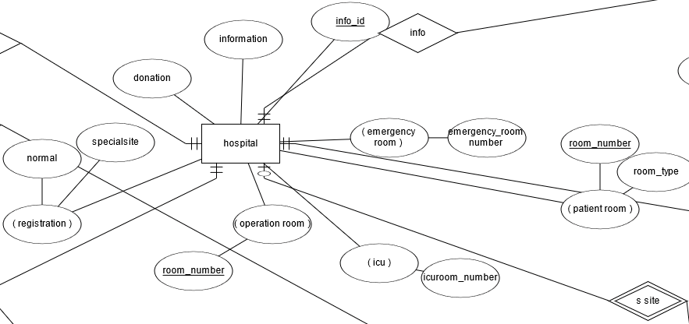

Prepared by: Maliha Mohasin
ID: 2019-1-60-171

Patient details: It keeps patients’ personal information like name, id, address, age, phone number, patient disease, previous doctor name, symptoms of the disease, and many more.
E-R Diagram:
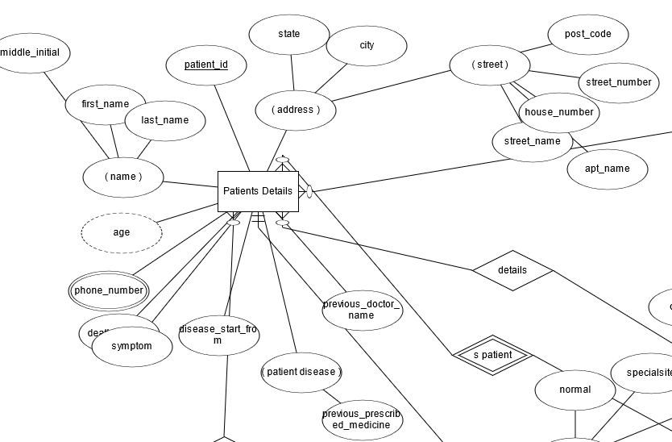

Prepared by: Maliha Mohasin
ID: 2019-1-60-171

Doctor details: It keeps the information about name, id, address, education, training from, a specialist in which sector and also when did he or she be available in. It mainly keeps the background of the doctor and other chambers’ information.
E-R Diagram:

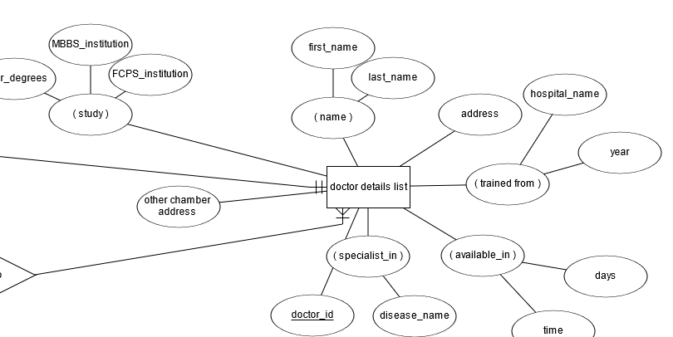

Prepared by: Maliha Mohasin
ID: 2019-1-60-171

Nurse details: In nurse details, it keeps the information about name, id, address, age, study, where did he or she trained from, how many days he or she works, which floor or building he or she work.
E-R Diagram:

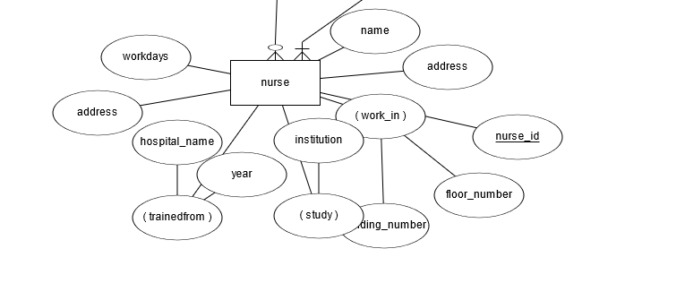
Prepared by: Maliha Mohasin
ID: 2019-1-60-171

Ward boy details: It keeps the information about his name, id, address, work floor. Word boy has a specific name who is aids patients with hygiene and related activities. He also provides patients with meals on time, following hospital rules and regulations and operating procedures. They also help nursing and medical staff.

E-R Diagram:

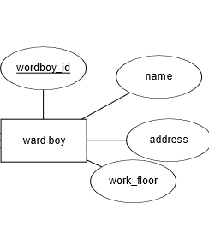
Prepared by: Maliha Mohasin
ID: 2019-1-60-171

Bill: When a patient is admitted to the hospital, she or he has to pay the bill. It keeps the information about admission date, discharge date, total bill, and bill-related other things and after paying the bill patient can discharge from the hospital.
E-R Diagram:

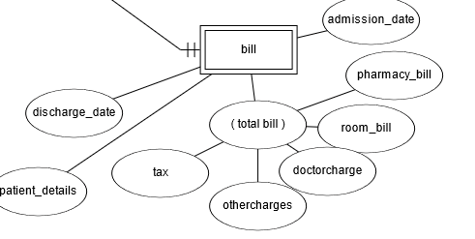

Prepared by: Maliha Mohasin
ID: 2019-1-60-171

Special site: There is a special site where anyone can go and check the checkup dates, time, free treatment, donation system.
E-R Diagram:
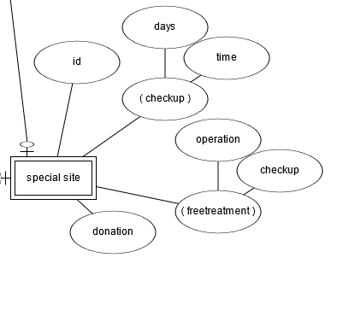
Prepared by: Maliha Mohasin
ID: 2019-1-60-171

Cardinality constraints and participation:

ER Diagram:

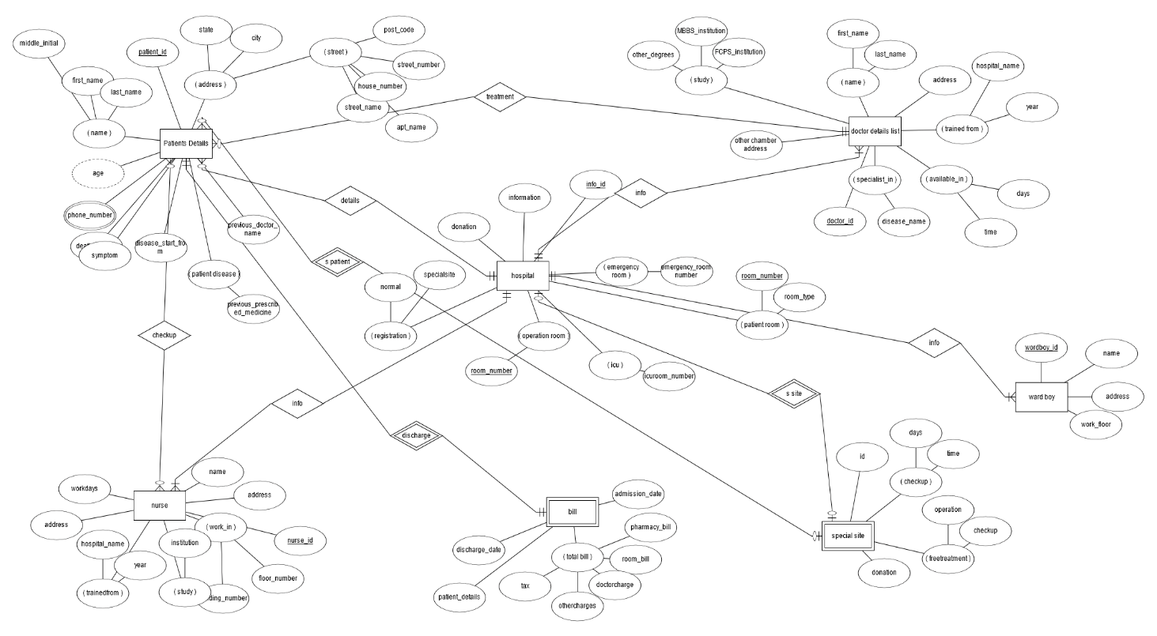

Prepared by: Maliha Mohasin , Fatema Tuj Johora
ID: 2019-1-60-171 ID: 2019-1-60-198

Relational Schema:

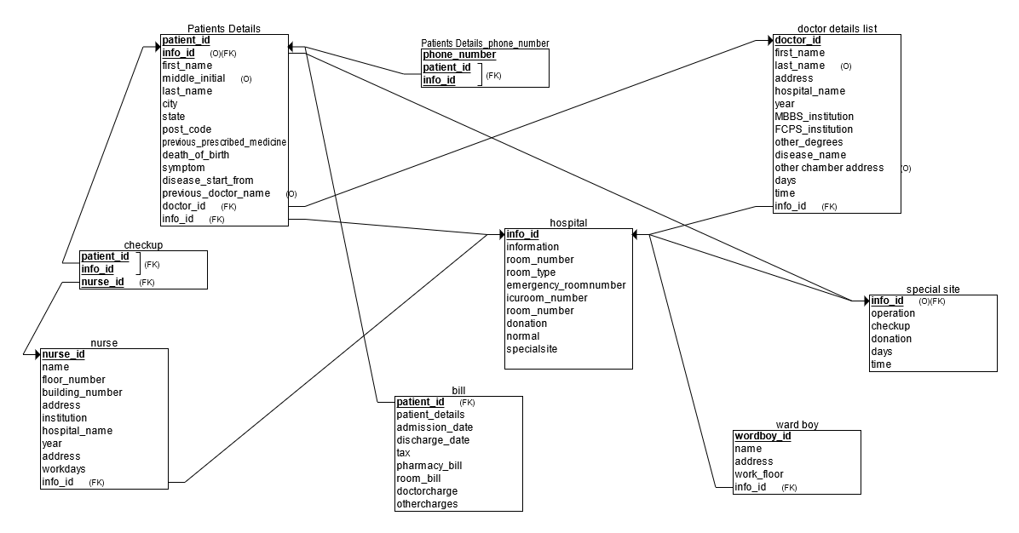

Prepared by: Maliha Mohasin , Fatema Tuj Johora
ID: 2019-1-60-171 ID: 2019-1-60-198

SQL Schema:
CREATE TABLE hospital
(
information VARCHAR(40) NOT NULL,
room_number VARCHAR(5) NOT NULL,
room_type VARCHAR(10) NOT NULL,
emergency_roomnumber VARCHAR(5) NOT NULL,
icuroom_number VARCHAR(5) NOT NULL,
donation VARCHAR(10) NOT NULL,
normal VARCHAR(10) NOT NULL,
specialsite VARCHAR(10) NOT NULL,
info_id INT NOT NULL,
PRIMARY KEY (info_id)
);
CREATE TABLE doctor_details_list
(
first_name VARCHAR(10) NOT NULL,
last_name VARCHAR(10),
address VARCHAR(30) NOT NULL,
hospital_name VARCHAR(20) NOT NULL,
year VARCHAR(5) NOT NULL,
MBBS_institution VARCHAR(30) NOT NULL,
FCPS_institution VARCHAR(30) NOT NULL,
other_degrees VARCHAR(50) NOT NULL,
disease_name VARCHAR(20) NOT NULL,
other_chamber_address VARCHAR(30),
days VARCHAR(10) NOT NULL,
time VARCHAR(10) NOT NULL,
doctor_id INT NOT NULL,
info_id INT NOT NULL,
PRIMARY KEY (doctor_id),
FOREIGN KEY (info_id) REFERENCES hospital(info_id)
);

CREATE TABLE nurse
(
nurse_id INT NOT NULL,
name VARCHAR(30) NOT NULL,
floor_number VARCHAR(2) NOT NULL,
building_number VARCHAR(5) NOT NULL,
address VARCHAR(50) NOT NULL,
institution VARCHAR(30) NOT NULL,
hospital_name VARCHAR(20) NOT NULL,
year VARCHAR(5) NOT NULL,
workdays VARCHAR(10) NOT NULL,
info_id INT NOT NULL,
PRIMARY KEY (nurse_id),
FOREIGN KEY (info_id) REFERENCES hospital(info_id)
);

CREATE TABLE special_site
(
operation VARCHAR(10) NOT NULL,
checkup VARCHAR(10) NOT NULL,
donation VARCHAR(10) NOT NULL,
days VARCHAR(10) NOT NULL,
time VARCHAR(10) NOT NULL,
info_id INT,
PRIMARY KEY (info_id),
FOREIGN KEY (info_id) REFERENCES hospital(info_id)
);
CREATE TABLE Patients_Details
(
patient_id INT NOT NULL,
first_name VARCHAR(10) NOT NULL,
middle_initial VARCHAR(10),
last_name VARCHAR(10) NOT NULL,
city VARCHAR(10) NOT NULL,
state VARCHAR(10) NOT NULL,
post_code VARCHAR(5) NOT NULL,
previous_prescribed_medicine VARCHAR(50) NOT NULL,
date_of_birth VARCHAR(10) NOT NULL,
symptom VARCHAR(50) NOT NULL,
disease_start_from VARCHAR(10) NOT NULL,
previous_doctor_name VARCHAR(20),
info_id INT,
doctor_id INT NOT NULL,
PRIMARY KEY (patient_id, info_id),
FOREIGN KEY (info_id) REFERENCES special_site(info_id),
FOREIGN KEY (doctor_id) REFERENCES doctor_details_list(doctor_id),
FOREIGN KEY (info_id) REFERENCES hospital(info_id)
);

CREATE TABLE bill
(
patient_details VARCHAR(30) NOT NULL,
admission_date VARCHAR(10) NOT NULL,
discharge_date VARCHAR(10) NOT NULL,
tax NUMERIC(2.1) NOT NULL,
pharmacy_bill VARCHAR(10) NOT NULL,
room_bill VARCHAR(10) NOT NULL,
doctorcharge VARCHAR(10) NOT NULL,
othercharges VARCHAR(10) NOT NULL,
patient_id INT NOT NULL,
PRIMARY KEY (patient_id),
FOREIGN KEY (patient_id) REFERENCES Patients_Details(patient_id)
);

CREATE TABLE checkup
(
patient_id INT NOT NULL,
info_id INT NOT NULL,
nurse_id INT NOT NULL,
PRIMARY KEY (patient_id, info_id, nurse_id),
FOREIGN KEY (patient_id, info_id) REFERENCES Patients_Details(patient_id, info_id),
FOREIGN KEY (nurse_id) REFERENCES nurse(nurse_id)
);

CREATE TABLE Patients_Details_phone_number
(
phone_number INT NOT NULL,
patient_id INT NOT NULL,
info_id INT NOT NULL,
PRIMARY KEY (phone_number, patient_id, info_id),
FOREIGN KEY (patient_id, info_id) REFERENCES Patients_Details(patient_id, info_id));

Prepared by: Maliha Mohasin , Fatema Tuj Johora , Sanat Kumar Mollick
ID: 2019-1-60-171 ID: 2019-1-60-198 ID: 2019-1-60-166

Insertion of sample values:
INPUT Part:
#Hospital
INSERT INTO hospital VALUES ('East West Hospital','50','2','10','5','500000','Yes','No',500);
INSERT INTO hospital VALUES ('East West Hospital','60','3','15','7','600000','No','Yes',500);
INSERT INTO hospital VALUES ('East West Hospital','70','1','20','9','700000','Yes','No',500);
INSERT INTO hospital VALUES ('East West Hospital','80','2','25','10','800000','No','Yes',500);
INSERT INTO hospital VALUES ('East West Hospital','90','1','30','15','900000','Yes','No',500);

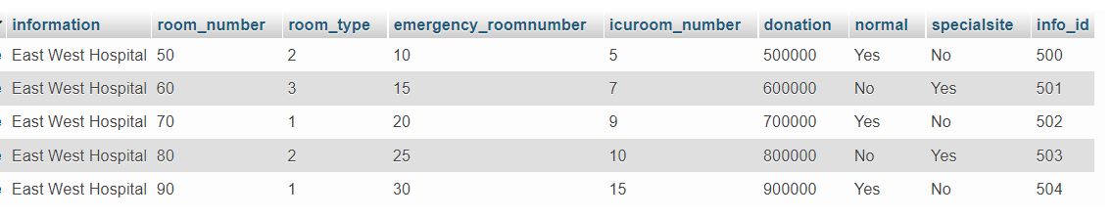

#Doctor_details_list
INSERT INTO doctor_details_list VALUES ('Dr.Angan','Mollick','Banasree','DMC','2010','DMC','DMC','MD','Medicine','Square Hospital','SAT-SUN','3:30-8:30',10,500);
INSERT INTO doctor_details_list VALUES ('Dr.Fatema','Tuj','Rampura','DNMC','2009','IMC','BMCH','MS','Colorectal Surgery','Ibne Sina Hospital','SAT-WED','10:30-1:30',11,501);
INSERT INTO doctor_details_list VALUES ('Dr.Maliha','Mohasin','Gulshan','IMC','2014','DMC','DNMC','MS','Colorectal Surgery','Crecent Hospital','WED-SUN','2:30-5:30',12,502);
INSERT INTO doctor_details_list VALUES ('Dr.Sadia','Afrin','Airport','BMCH','2007','BMCH','IMC','MPhill','Ortho Surgery','Japan Bangladesh Hospital','FRI-TUE','1:30-3:30',13,503);
INSERT INTO doctor_details_list VALUES ('Dr.TAmzid','Inam','Uttara','DMC','2012','DMC','IMC','MD','Medicine','Farazy Hospital','SAT-WED','9:30-2:30',14,504);
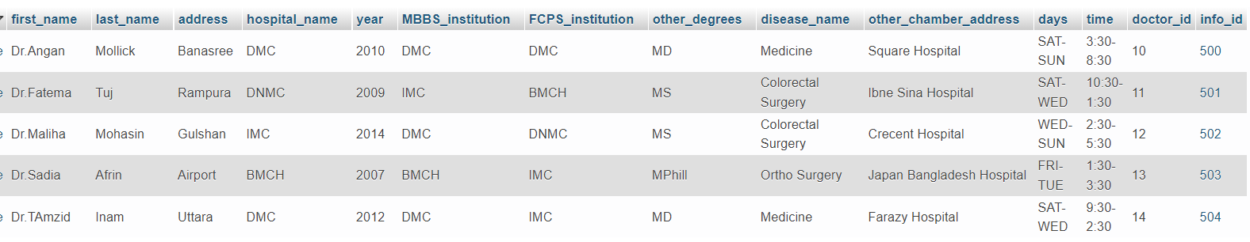

#Nurse
INSERT INTO nurse VALUES (99,'Sokhina Akter',1,'01','Aftabnagar','Dhaka Nursing College','East West Hopital','2020','SAT-FRI',500);
INSERT INTO nurse VALUES (100,'Jorina Akter',1,'02','Komolapur','Narshingdi Nursing College','East West Hopital','2016','SAT-FRI',501);
INSERT INTO nurse VALUES (101,'Asma Akter',2,'01','Badda','Tongi Nursing College','East West Hopital','2019','SAT-FRI',502);
INSERT INTO nurse VALUES (102,'Fatema Akter',2,'02','Rupnagar','Badda Nursing College','East West Hopital','2012','SAT-FRI',503);
INSERT INTO nurse VALUES (103,'Julekha Akter',1,'01','Aftabnagar','Uttara Nursing College','East West Hopital','2013','SAT-FRI',504);

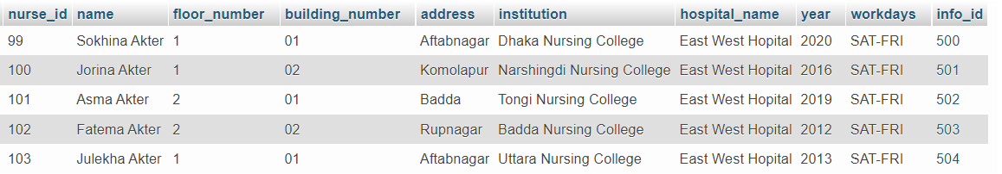

#Special_site
INSERT INTO special_site VALUES ('No','Yes','00','3rd','3:30',500);
INSERT INTO special_site VALUES ('Yes','Yes','1000','2nd','8:30',501);
INSERT INTO special_site VALUES ('No','Yes','500','3rd','6:30',502);
INSERT INTO special_site VALUES ('No','Yes','00','1st','2:30',503);
INSERT INTO special_site VALUES ('Yes','Yes','3000','6th','11:30',504);
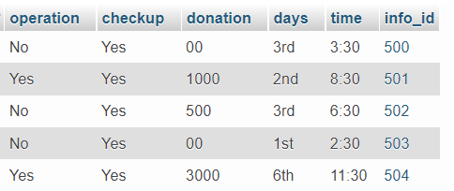

#Patients_details_phone_number
INSERT INTO patients_details_phone_number VALUES (01704899428,1,500);
INSERT INTO patients_details_phone_number VALUES (01809776216,2,501);
INSERT INTO patients_details_phone_number VALUES (01881021483,3,502);
INSERT INTO patients_details_phone_number VALUES (01918150362,4,503);
INSERT INTO patients_details_phone_number VALUES (01912222271,5,504);
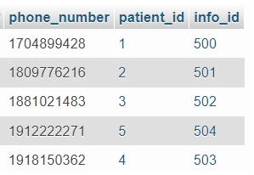
#Checkup
INSERT INTO checkup VALUES (1,500,99);
INSERT INTO checkup VALUES (2,501,100);
INSERT INTO checkup VALUES (3,502,101);
INSERT INTO checkup VALUES (4,503,102);
INSERT INTO checkup VALUES (5,504,103);

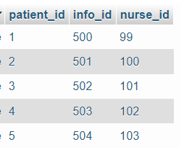

#Bill
INSERT INTO bill VALUES ('Rafid Mahmud haque','10-1-22','14-1-22',900,'1590','4000','2000','500',1);
INSERT INTO bill VALUES ('Tanvir Mahmud haque','8-1-22','13-1-22',1200,'1800','5000','2000','500',2);
INSERT INTO bill VALUES ('Sourav Kumar Saha','6-1-22','11-1-22',1200,'1670','5000','2000','500',3);
INSERT INTO bill VALUES ('Nafisa Binte Nayeem','7-1-22','12-1-22',1200,'2430','5000','2000','500',4);
INSERT INTO bill VALUES ('Najmul Hasan Rahat','8-1-22','14-1-22',1500,'3000','6000','2000','500',5);
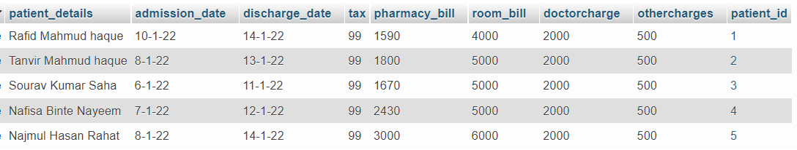

#Patient_details
INSERT INTO patients_details VALUES (1,'Rafid','Mahmud','haque','Dhaka','Dhaka','2340','No','12-4-00','Liver Pain','10-1-22','No',10,500);
INSERT INTO patients_details VALUES (2,'Tanvir','Mahmud','haque','Ctg','Ctg','1254','Yes','12-4-00','Back Pain','8-1-22','Dr. Nadim',11,501);
INSERT INTO patients_details VALUES (3,'Sourav','Kumar','Saha','Cumilla','cumilla','3214','Yes','12-4-00','Leg Pain','5-1-22','No',12,502);
INSERT INTO patients_details VALUES (4,'Nafisa','Binte','Nayeem','Barishal','Barishal','5414','No','12-4-00','neck Pain','6-1-22','Dr. Ahmed',13,503);
INSERT INTO patients_details VALUES (5,'Najmul','Hasan','Rahat','Dhaka','Dhaka','2813','Yes','12-4-00','Tumour','12-12-21','No',14,504);
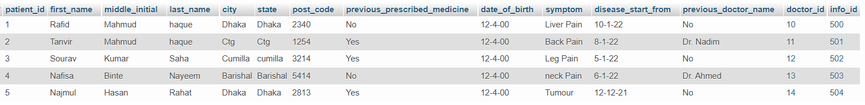

#Ward_boy
INSERT INTO ward_boy VALUES ( 111,'Ridoy','Aftabnagar','1',500);
INSERT INTO ward_boy VALUES ( 112,'Sajib','Mohakhali','1',501);
INSERT INTO ward_boy VALUES ( 113,'Karim','Aftabnagar','2',502);
INSERT INTO ward_boy VALUES ( 114,'Rahman','Kakoli','2',503);
INSERT INTO ward_boy VALUES ( 115,'Ashik','Badda','1',504);

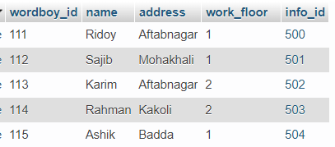

Prepared by: Sanat Kumar Mollick
ID: 2019-1-60-166

Join Queries:
1.find patient who have Liver Pain and met with Dr. Angan

SELECT*
FROM patients_details AS p INNER JOIN doctor_details_list AS d
WHERE p.symptom = 'Liver Pain' and d.info_id = 500

2.Find all patients who are apointed with all doctors.

SELECT*
FROM patients_details as p
LEFT OUTER JOIN doctor_details_list d
ON p.patient_id = d.doctor_id
ORDER BY p.patient_id

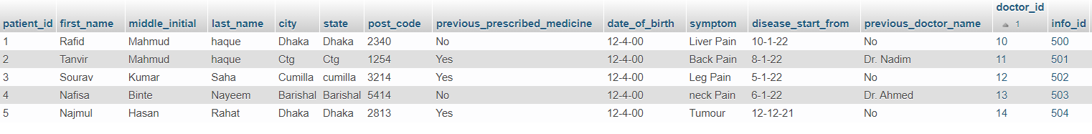
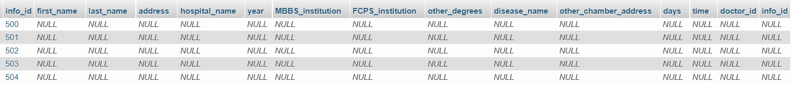

3.Find the patient live in Ctg and the doctor who live in Banasree.

SELECT*
FROM patients_details AS p INNER JOIN doctor_details_list AS d
WHERE p.city = 'Ctg' and d.address = 'Banasree'

4.find all nurse who appointed with all patients.
SELECT*
FROM nurse as n
LEFT OUTER JOIN checkup c
ON n.nurse_id = c.info_id
ORDER BY n.nurse_id

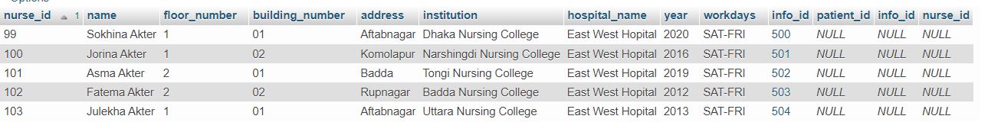

5.find all nurse who help in checkup.

SELECT*
FROM nurse as n
RIGHT OUTER JOIN checkup c
ON n.nurse_id = c.info_id
ORDER BY n.nurse_id

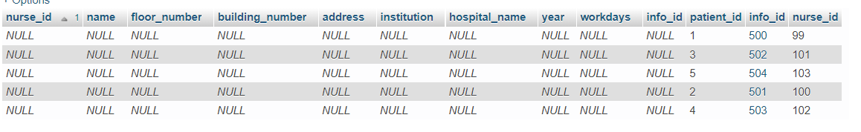

6.Find all patients details with their bill.
SELECT*
FROM patients_details AS p INNER JOIN bill AS b
WHERE p.patient_id = b.patient_id
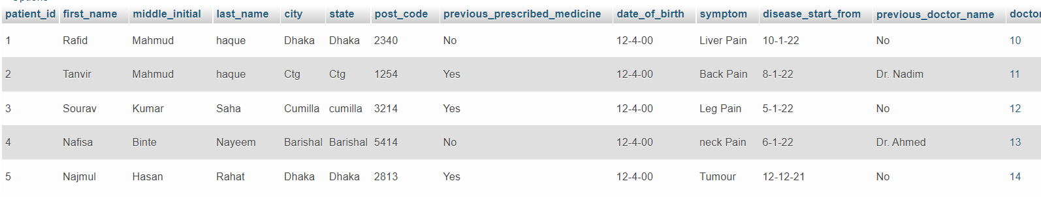

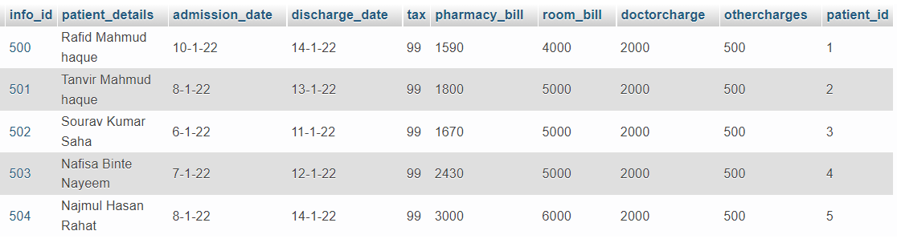

Prepared by: Sanat Kumar Mollick ,
ID: 2019-1-60-166

Update & Delete Queries:

Update:
Update Doctor Name.

UPDATE doctor_details_list
SET first_name = 'Dr.Skm'
WHERE first_name ='Dr.Angan'

Before update:
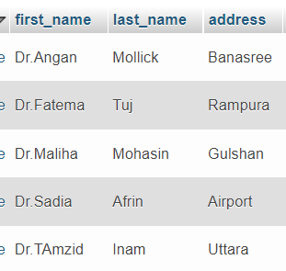

After update:
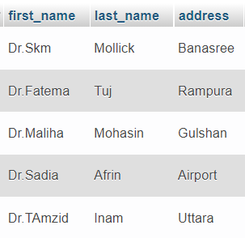

Delete:
Delete Patient from bill.

DELETE
FROM bill
WHERE patient_id = 1

Before delete:
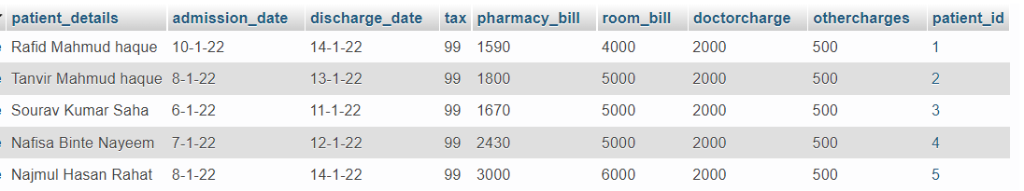

After Delete:
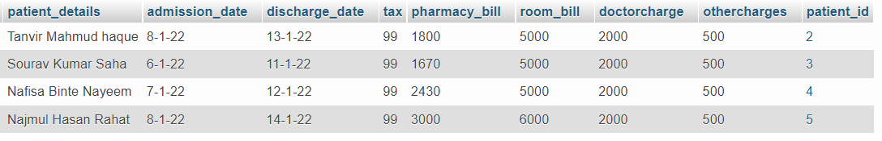

Prepared by: Sanat Kumar Mollick
ID: 2019-1-60-166

Conclusion: Considering all of the above, we can deduce that the hospital management system is an unavoidable element of the modern medical institution's lifecycle. It streamlines user interactions by automating a variety of daily tasks. Developing hospital system software is a fantastic way to establish a unique, efficient, and quick healthcare delivery model. The implementation of a hospital management system project aids in the storage of all types of records, the provision of coordination and user communication, the implementation of policies, the improvement of day-to-day operations, the organization of supply chains, the management of financial and human resources, and the marketing of hospital services. This advantageous option meets the needs of patients, employees, and hospital authorities while also simplifying interactions between them. It has become the standard method of hospital administration.

Prepared by: Sanat Kumar Mollick
ID: 2019-1-60-166

